INTERNATIONAL TELECOMMUNICATION UNION |  | STUDY GROUP 9
TELECOMMUNICATION  STANDARDIZATION SECTOR  STUDY PERIOD 2009-2012 |  | TD ??
English only
Original: English
Question(s): | 2/9 | Geneva, 26-30 October 2009
TEMPORARY DOCUMENT
Source: | Editors
Title: | Draft Recommendation J.vqhdtv-rr for progressing
<Recommendation No.>

Objective perceptual multimedia video quality measurement of HDTV
for digital cable television in the presence of a reduced reference
Summary
This Recommendation provides guidelines on the selection of appropriate objective perceptual video quality measurement methods for HDTV when a reduced reference signal is available. The following are example applications that can use this Recommendation:
1. Interlaced video television streams over cable networks including those transmitted over the Internet using Internet Protocol.
2. Some forms of IPTV video payloads.
3. Video quality monitoring at the receiver when side-channels are available.
4. Video quality monitoring at measurement nodes located between point of transmission and point of reception.

1 Scope
This HDTV-RR Test addresses the following video formats:
- 1080i 60 Hz (30 fps)
- 1080p (25 fps)
- 1080i 50 Hz (25 fps)
- 1080p (30 fps)
- 720p 60 Hz (60 fps)
- 720p 50 Hz (50 fps)
Reduced reference (RR) models have limited bandwidth access to the source video. For RR models to operate correctly, the unimpaired source video should be available for the models to extract parameters.
The HRCs in each experiment spanned both coding only artifacts and coding with transmission errors. The coding schemes examined were MPEG-2 and H.264 (MPEG-4 part 10). The encoders were run at a variety of bit-rates from 1.0 to 30 Mbit/s.

Although the models defined in this Recommendation may be used to compare video system performance (e.g., comparing two codecs) the reader should be aware that the models contained in this recommendation were not validated for such applications.
None of the evaluated models reached the accuracy of the normative subjective testing.

1.1 Applications
The applications for the estimation models described in this Recommendation include but are not limited to:
1) potentially real-time, in-service quality monitoring at the source;
2) remote destination quality monitoring when side-channels are available for features extracted from source video sequences;
3) quality measurement for monitoring of a storage or transmission system that utilizes video compression and decompression techniques, either a single pass or a concatenation of such techniques.
4) lab testing of video systems.

1.2 Limitations

The estimation models described in this Recommendation cannot be used to fully replace subjective testing. Correlation values between two carefully designed and executed subjective tests (i.e. in two different laboratories) normally fall within the range 0.93 to 0.98. If this Recommendation is utilized to make video system comparisons (e.g., comparing two codecs), it is advisable to use a quantitative method (such as that in J.149) to determine the models’ accuracy for that particular context.
The models in this Recommendation were validated by measuring video that exhibits frame freezes up to 2 seconds.
The models in this Recommendation were not validated for measuring video that has a steadily increasing delay (e.g. video which does not discard missing frames after a frame freeze).
For detailed test conditions and calibration limits under which the models were validated the potential user is referred to the HDTV testplan published by VQEG.
It should be noted that in case of new coding and transmission technologies producing artifacts which were not included in this evaluation, the objective models may produce erroneous results. Here a subjective evaluation is required.

2 References
The following ITU-T Recommendations and other references contain provisions, which, through reference in this text, constitute provisions of this Recommendation. At the time of publication, the editions indicated were valid. All Recommendations and other references are subject to revision; users of this Recommendation are therefore encouraged to investigate the possibility of applying the most recent edition of the Recommendations and other references listed below. A list of the currently valid ITU-T Recommendations is regularly published.
The reference to a document within this Recommendation does not give it, as a stand-alone document, the status of a Recommendation.

[ITU-T P.910] Recommendation ITU-T P.910 (2008), Subjective video quality assessment methods for multimedia applications.
[ITU-T P.911] Recommendation ITU-T P.911 (1998), Subjective audiovisual quality assessment methods for multimedia applications.
[ITU-T J.143] Recommendation ITU-T J.143 (2000), User requirements for objective perceptual video quality measurements in digital cable television.
[ITU-T J.244] Recommendation ITU-T J.244 (2008), Calibration methods for constant misalignment of spatial and temporal domains with constant gain and offset
[ITU-R BT.500-11] Recommendation ITU-R BT.500-11 (2002), Methodology for the subjective assessment of the quality of television pictures.

3 Definitions
This recommendation uses the following terms defined elsewhere.

3.1 Terms defined elsewhere:
This Recommendation uses the following terms defined elsewhere:
3.1.1 subjective assessment (picture) [ITU-T J.144]: The determination of the quality or impairment of programme like pictures presented to a panel of human assessors in viewing sessions.
3.1.2 objective perceptual measurement (picture) [ITU-T J.144]: The measurement of the performance of a programme chain by the use of programme-like pictures and objective (instrumental) measurement methods to obtain an indication that approximates the rating that would be obtained from a subjective assessment test.
3.1.3 proponent [ITU-T J.144]: An organization or company that proposes a video quality model for validation testing and possible inclusion in an ITU Recommendation.

3.2 Terms defined in this Recommendation
This Recommendation defines the following terms:
3.2.1 Frame rate: is defined as the number of unique frames (i.e., total frames – repeated frames) per second
3.2.2 Simulated transmission errors: are defined as errors imposed upon the digital video bit stream in a highly controlled environment. Examples include simulated packet loss rates and simulated bit errors. Parameters used to control simulated transmission errors are well defined
3.2.3 Transmission errors: are defined as any error imposed on the video transmission. Example types of errors include simulated transmission errors and live network conditions

4 Abbreviations and acronyms
This Recommendation uses the following abbreviations and acronyms:
ACR Absolute Category Rating (see P.910)
ACR-HR Absolute Category Rating with Hidden Reference (see P.910)
AVI Audio Video Interleave
DMOS Difference Mean Opinion Score
FR Full Reference
FRTV Full Reference TeleVision
HRC Hypothetical Reference Circuit
ILG VQEG's Independent Laboratory Group
MOS Mean Opinion Score
MOSp Mean Opinion Score, predicted
NR No (or Zero) Reference
PSNR Peak Signal to Noise Ratio
PVS Processed Video Sequence
RMSE Root Mean Square Error
RR Reduced Reference
SFR Source Frame Rate
SRC Source Reference Channel or Circuit
VQEG Video Quality Experts Group
YUV Color Space and file format

5 Conventions
None.

6 Description of the reduced reference measurement methods

6.1 Introduction
Although PSNR has been widely used as an objective video quality measure, it is also reported that it does not well represent perceptual video quality. By analyzing how humans perceive video quality, it is observed that the human visual system is sensitive to degradation around the edges. In other words, when the edge pixels of a video are blurred, evaluators tend to give low scores to the video even though the PSNR is high. Based on this observation, the reduced reference models which mainly measure edge degradations have been developed.

Figure 6.1 illustrates how a reduced-reference model works. Features which will be used to measure video quality at a monitoring point are extracted from the source video sequence and transmitted. The Table 6.1 shows the side-channel bandwidths for the features, which have been tested in the VQEG RRNR-TV test.

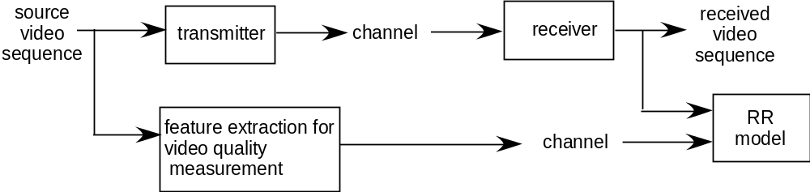
Figure 6.1. Block diagram of reduced reference model.

Table 6.1 Side-channel bandwidths.

Video Format | Tested Bandwidths
1080i 60 Hz (30 fps)  1080p (30 fps) | 56kbps, 128kbps, 256kbps
1080p (25 fps)  1080i 50 Hz (25 fps) | 56kbps, 128kbps, 256kbps

6.2 The EPSNR Reduced-Reference Models

6.2.1 Edge PSNR (EPSNR)
The RR models mainly measure on edge degradations. In the models, an edge detection algorithm is first applied to the source video sequence to locate the edge pixels. Then, the degradation of those edge pixels is measured by computing the mean squared error. From this mean squared error, the edge PSNR is computed.
One can use any edge detection algorithm, though there may be minor differences in the results. For example, one can use any gradient operator to locate edge pixels. A number of gradient operators have been proposed. In many edge detection algorithms, the horizontal gradient image g_{horizontal}(m,n) and the vertical gradient image g_{vertical}(m,n) are first computed using gradient operators. Then, the magnitude gradient image 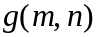 may be computed as follows:
Finally, a thresholding operation is applied to the magnitude gradient image to find edge pixels. In other words, pixels whose magnitude gradients exceed a threshold value are considered as edge pixels.
Figures 6.2-6 illustrate the procedure. Figure 6.2 shows a source image. Figure 6.3 shows a horizontal gradient image g_{horizontal}(m,n), which is obtained by applying a horizontal gradient operator to the source image of Figure 6.2. Figure 6.4 shows a vertical gradient image g_{vertical}(m,n), which is obtained by applying a vertical gradient operator to the source image of Figure 6.2. Figure 6.5 shows the magnitude gradient image (edge image) and Figure 6.6 shows the binary edge image (mask image) obtained by applying thresholding to the magnitude gradient image of Figure 6.5.


Figure 6.2. A source image (original image).

Figure 6.3. A horizontal gradient image, which is obtained by applying a horizontal
gradient operator to the source image of Figure 6.2.

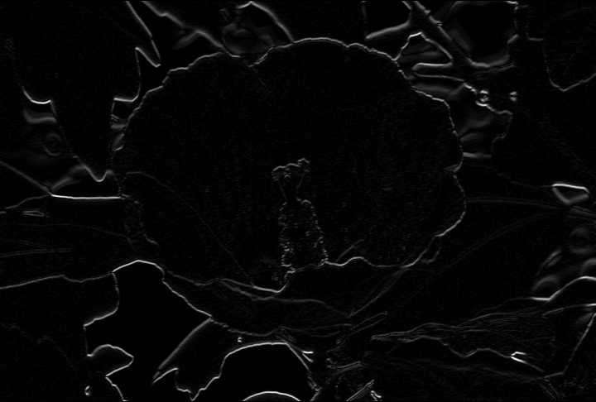
Figure 6.4. A vertical gradient image, which is obtained by applying a vertical
gradient operator to the source image of Figure 6.2.

Figure 6.5. A magnitude gradient image.


Figure 6.6. A binary edge image (mask image) obtained by applying thresholding
to the magnitude gradient image of Figure 6.5.
Alternatively, one may use a modified procedure to find edge pixels. For instance, one may first apply a vertical gradient operator to the source image, producing a vertical gradient image. Then, a horizontal gradient operator is applied to the vertical gradient image, producing a modified successive gradient image (horizontal and vertical gradient image). Finally, a thresholding operation may be applied to the modified successive gradient image to find edge pixels. In other words, pixels of the modified successive gradient image, which exceed a threshold value, are considered as edge pixels. Figures 6.7-10 illustrate the modified procedure. Figure 6.7 shows a vertical gradient image g_{vertical} (m,n), which is obtained by applying a vertical gradient operator to the source image of Figure 6.2. Figure 6.8 shows a modified successive gradient image (horizontal and vertical gradient image), which is obtained by applying a horizontal gradient operator to the vertical gradient image of Figure 6.7. Figure 6.9 shows the binary edge image (mask image) obtained by applying thresholding to the modified successive gradient image of Figure 6.8.

Figure 6.7. A vertical gradient image, which is obtained by applying a vertical
gradient operator to the source image of Figure 6.2.

Figure 6.8. A modified successive gradient image (horizontal and vertical gradient image), which is obtained by applying a horizontal gradient operator to the vertical gradient image of Figure 6.7.


Figure 6.9. A binary edge image (mask image) obtained by applying thresholding
to the modified successive gradient image of Figure 6.8.

It is noted that both methods can be understood as an edge detection algorithm. One may choose any edge detection algorithm depending on the nature of videos and compression algorithms. However, some methods may outperform other methods.
Thus, in the model, an edge detection operator is first applied, producing edge images (Figure 6.5 and Figure 6.8). Then, a mask image (binary edge image) is produced by applying thresholding to the edge image (Figure 6.6 and Figure 6.9). In other words, pixels of the edge image whose value is smaller than threshold t_{e} are set to zero and pixels whose value is equal to or larger than the threshold are set to a nonzero value. Figures 6.6 and 6.9 show some mask images. Since a video can be viewed as a sequence of frames or fields, the above-stated procedure can be applied to each frame or field of videos. Since the model can be used for field-based videos or frame-based videos, the terminology “image” will be used to indicate a field or frame.

7 Findings of the Video Quality Experts Group (VQEG)

This document presents results from the Video Quality Experts Group (VQEG) HDTV validation testing of objective video quality models. This document provides input to the relevant standardization bodies responsible for producing international Recommendations and regional Standards.
The High Definition Television (HDTV) Test contains two parallel evaluations of test video material. One evaluation is by panels of human observers (i.e., subjective testing). The other is by objective computational models of video quality (i.e., proponent models). The objective models are meant to predict the subjective judgments. Each subjective test will be referred to as an “experiment” throughout this document.
This HDTV Test addresses four video formats directly (1080p at 25 and 29.97 frames-per-second, and 1080i at 50 and 59.94 fields-per second) and two video formats indirectly (720p at 50 and 59.94 frames-per-second). This HDTV Test addressed three types of models: full reference (FR), reduced reference (RR), and no reference (NR). FR models have full access to the source video; RR models have limited bandwidth access to the source video; and NR models do not have access to the source video.
Six subjective experiments provided data against which model validation was performed. The experiments were divided between the four 1080 video formats. 720p was inserted into experiments as a test condition, for example by converting 1080i 59.94 fields-per-second video to 720p 59.94 frames-per-second, compressing the video, and then converting back to 1080i. A common set of carefully chosen video sequences were inserted identically into each experiment, to anchor the video experiments to one another and assist in comparisons between the subjective experiments. These common sequences were used to map the six experiments onto a single scale (called the “aggregated superset” in this report). The subjective experiments included processed video sequences with a wide range of quality. The impairments examined were restricted to MPEG-2 and H.264, both coding only and coding plus transmission errors.
A total of 12 independent testing laboratories coordinated to perform subjective testing (AGH University, Psytechnics, NTIA/ITS, Ghent University – IBBT, Verizon, Intel, FUB, CRC, Acreo, Ericsson, IRCCyN, and Deutsch Telekom AG Laboratories). Objective models were submitted after the six secret experiments were near completion (e.g., after scene selection, PVS generation, and most of the subjective testing) to allow proponents the best opportunity to improve their model. 14 models were submitted, 6 were withdrawn, and 8 are presented in this report.

MODEL PERFORMANCE EVALUATION TECHNIQUES
The models were evaluated using two statistics that provide insights into model performance: Root-Mean Squared Error (RMSE) and Pearson Correlation. Each model was fitted to each subjective experiment and the aggregated superset, by optimizing Pearson Correlation with subjective data first, and minimizing RMSE second. RMSE is considered the primary metric for analysis in this report. Thus, RMSE is used to determine whether a model is in the group of top performing models for one video format/resolution (i.e. a group of models that include the top performing model and models that are statistically equivalent to the top performing model).
When examining the total number of times a model is statistically equivalent to the top performing model, comparisons between models should be performed carefully. Determining which differences in totals are statistically significant requires additional analysis that is not available. As a general guideline, small differences in these totals do not indicate an overall difference in performance. This refers to the tables below.
PSNR was computed as a reference measure, and compared to all models. PSNR was computed using an exhaustive search for calibration and one constant delay for each video sequence. PSNR was calculated according to ITU-T Draft Rec. J.340, which included temporal and spatial calibration. However, to save computation time, the luminance gain & offset calculation for PSNR were calculated separately and input to the PSNR algorithm as constants, and an appropriate search range was chosen for each dataset. Models were required to perform their own calibration, where needed.

RR MODEL PERFORMANCE
RR models were submitted by Yonsei for the following bit-rates: 56 kbits/s, 128 kbits/s, and 256 kbits/s. When comparing these RR models to PSNR, it must be noted that PSNR is an FR model (i.e., PSNR needs full access to the source video). Thus, equivalence to PSNR indicates that the RR model showed good performance while using a lower bandwidth.
Primary Analysis of RR Models
The performance of each RR model is summarized in the table below. “Superset RMSE” identifies the primary metric (RMSE) computed on the aggregated superset (i.e., all six experiments mapped onto a single scale). “Top Performing Group Total” identifies the number of experiments (0 to 6) for which this model was either the top performing model or statistically equivalent to the top performing model. “Equivalent To or Better Than PSNR Total” identifies the number of experiments (0 to 6) for which the model was statistically equivalent to or better than PSNR. “Equivalent To Superset PSNR” lists whether each model is statistically equivalent to PSNR on the aggregated superset. “Superset Correlation” identifies the Pearson Correlation computed on the aggregated superset.
Metric | PSNR | Yonsei56k | Yonsei128k | Yonsei256k
Superset RMSE | 0.71 | 0.73 | 0.73 | 0.73
Top Performing Group Total | 6 | 4 | 4 | 4
Equivalent To or Better Than PSNR Total | 6 | 4 | 4 | 4
Equivalent To Superset PSNR | Yes | Yes | Yes | Yes
Superset Correlation | 0.78 | 0.77 | 0.77 | 0.77

The body of this report includes other metrics including Pearson Correlation & RMSE calculated on individual experiments, confidence intervals, statistical significance testing on individual experiments, analysis on subsets of the data that include specific impairments (e.g., H.264 coding-only), scatter plots, and the fit coefficients for each model.
RR Model Conclusions
- VQEG believes that some of the RR models may be considered for standardization making sure that the scopes of these Recommendations are written carefully to ensure that the use of the models is defined appropriately.
- If the scope of these Recommendations includes video system comparisons (e.g., comparing two codecs), then the Recommendation should include instructions indicating how to perform an accurate comparison.
- None of the evaluated models reached the accuracy of the normative subjective testing.
- All of the RR models performed statistically equivalent to or better than PSNR. It must be noted that PSNR is a FR model requiring full access to the source video.

______________

All NR models were withdrawn.

